The African Legacy in Latin America – IGS-333-26

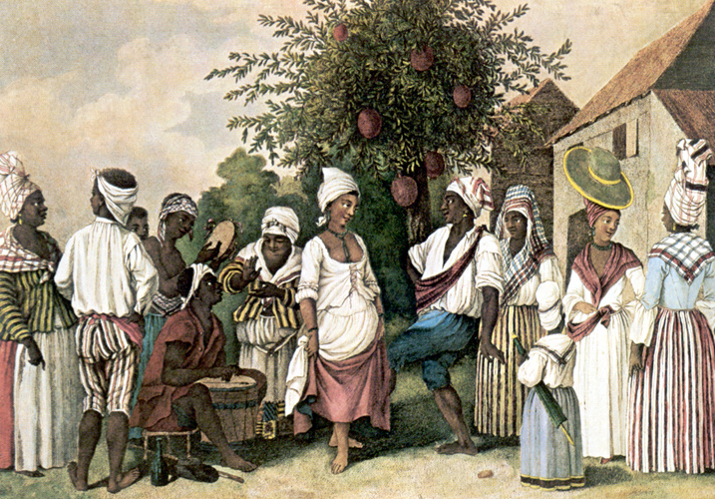 | 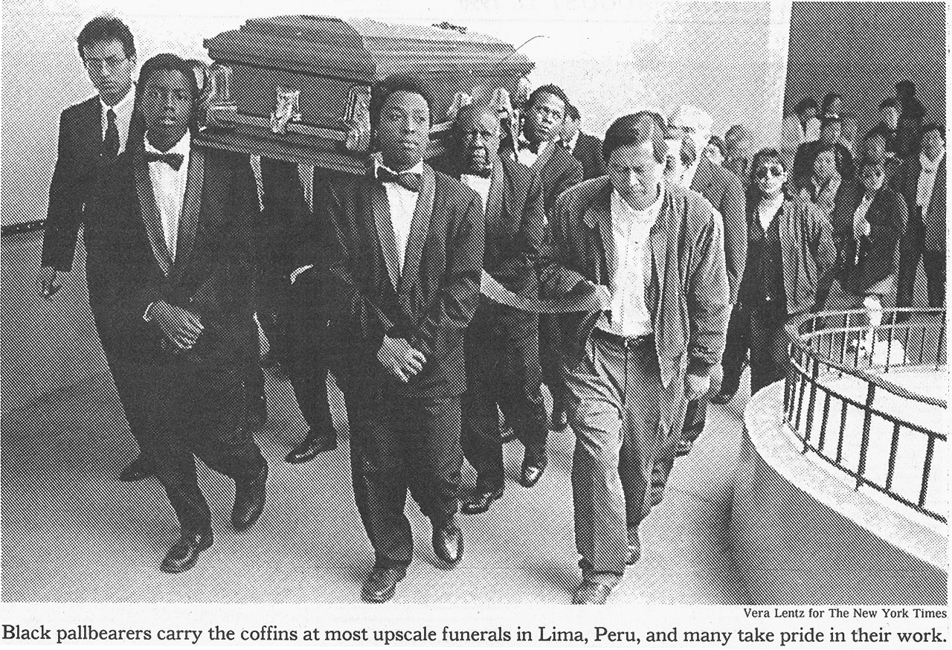

Tues. & Thurs. 3:30-4:45 PM Dr. Antonio de la Cova
Room SULV 201 Office hours: Tues-Thurs 2-3 PM
E-mail: ardelaco@uncg.edu or by appointment
Spring 2011 Office: Moore 3103

COURSE DESCRIPTION: A survey of the African heritage in Latin America from the 16th century to the present day. Emphasizes how Africans and their descendants went from slavery to freedom while responding to political, economic, and cultural changes in their diverse societies. It analyzes the history of people of African descent in every Latin American country from Mexico to Argentina.

COURSE REQUIREMENTS: In order to maximize student learning, there will be Power-Point lectures, YouTube video analysis, and textbook and BlackBoard assignment readings that require taking notes. Students are expected to use logical arguments sustained with evidence in class discussions and to improve their reading, writing, analytical, and speaking skills.

READINGS: You are expected to read the assigned texts and supplemental readings posted before each class via Blackboard. The readings will often portray opposing viewpoints to challenge intellectual inquiry. Questions regarding the texts and articles will appear on the midterm and final exams. Students are expected to come to class prepared to discuss the assigned readings. The required texts are:
Andrews, George Reid. Afro-Latin America 1800-2000. (Oxford University Press)
ISBN 0-19-515233-3
Klein, Herbert S. and Ben Vinson III. African Slavery in Latin America and the Caribbean.
(Oxford University Press) ISBN 0-195-18942-6
Scott, Rebecca J. Scott. Slave Emancipation in Cuba: The Transition to Free Labor, 1860-1899
(Princeton University Press) ISBN 0-691-10157-4
They can be acquired online or at the UNCG bookstore.

LATIN AMERICAN STUDIES WEBSITE: http://www.latinamericanstudies.org/
It contains topics and data related to this course and research paper sources.
http://www.latinamericanstudies.org/afro-latinamericans.htm

ELECTRONIC COMMUNICATION: Students are also expected to check the course website on BlackBoard on a regular basis, as important announcements, writing assignments, grades, and other items will be posted there. To access BlackBoard you need to activate your UNCG account. Then log in with your network and password.
https://blackboard.uncg.edu/webapps/portal/frameset.jsp

ATTENDANCE: Along with class discussion participation, constitutes 10% of your final grade. The roll will be taken at every class. If you come in after the roll has been taken, it is your responsibility to notify me right after class. Class notes will be taken by hand. No electronic devices are permitted in the classroom, including laptops, cell phones, and MP3 players, due to their distraction and disrespect caused to others. Do not display any of these items in the classroom, even if you arrive early, because you will be counted absent for that day. Absences totaling 5 classes will result in an F for the course. You need to focus and strike a balance between your schooling, employment, and social life to achieve outstanding grades.

CELL PHONE TEXTING: This addiction has grown to epic proportions. If you display a cell phone in the classroom, even before the class starts, or your cell phone accidentally rings in the room, you will be counted absent for that day. If you text during class lecture, your final course grade will drop one letter grade each time you do so.

EXAMS: The essay exams will test your mastery of course material and your ability to apply course concepts. You are responsible for your own class lecture notes. The course PowerPoint presentations will not be posted. The only study guides issued for this course are included in this syllabus and in the “Discussion Questions” section of BlackBoard. There is NO “Extra Credit.”

GRADING: Your grade will consist of a Mid-Term Exam (30%), a Final Exam (30%), a research paper (30%), and attendance and participation (10%). This is a crucial element in this course. We will spend much of our time discussing the ideas raised in the readings. The key criteria for assessing class participation are the amount and regularity of contributions and the degree to which these are thoughtful, informed, constructive and relevant. Additionally, supplemental information will be presented and discussed in class. The effort that you dedicate to this course will reflect your final grade.

MAKE-UP EXAM: Only given under a valid physician's excuse or verified family emergency. Makeups are different and considerably more difficult than the regularly scheduled test.

SCALE: (100-92=A), (91.9-90=A-), (89.9-88=B+), (87.9-82=B), (81.9-80= B-), (79.9-78=C+), (77.9-72=C), (71.9-70=C-), (69.9-68=D+), (67.9-62=D), (61.9-60=D-), (Below 59.9= F).

RESEARCH PAPER: Choose your own topic related to this course. The paper must be typed in Word or WordPerfect, 12-point font, double-spaced, with standard 1-inch margins, without illustrations. Do not use headers with dates and other course information. Papers are eight to ten pages in text length and include a minimum of three citations from the Latin American Studies web page, three books and three academic journals. A research prospectus, detailed outline, and bibliography are due by February 1. A late prospectus will drop one letter grade on the research paper. Turn in an electronic copy on BlackBoard. A late paper will drop one letter grade.

- COURSE SPECIFIC OUTCOMES: Upon successful completion of this course students will be able to:
- explain key terms, facts, and events of the African legacy in Latin America, thereby gaining an informed perspective
- comprehend the causes and effects of slave resistance, rebellion and emancipation in Latin America
- recognize the names, accomplishments and struggles Afro Latin American leaders
- define the differences of slave society and economy in the colonies of Spain, France, and England
- interpret the role of religion, art, music and literature of Afro Latin Americans
- evaluate primary source material and gain insight on how to interpret history and politics through such sources

STUDENT LEARNING OUTCOMES: By the end of the course, students will be able to:
- critically appraise varying arguments and to clearly express their own interpretations
- critically read and distinguish between different types of sources and to “read between the lines” of differing points of view
- analyze course-related documents and data and apply principles and generalizations learned in the class to other problems and situations
- demonstrate an openness to new ideas and the capacity to think critically
- apply methods of comparative political analysis and demonstrate their understanding that history is not just the memorization of dates and facts, but rather the interpretation of the past

ACADEMIC INTEGRITY POLICY: The UNCG Honor Code applies to all your course assignments. http://academicintegrity.uncg.edu/complete/ Plagiarism and cheating will be dealt with under the UNCG Student Code of Conduct. http://studentconduct.uncg.edu/policy/code/

WRITING CENTER: The UNCG Writing Center http://www.uncg.edu/eng/writingcenter/ can provide assistance at any stage of a writing project, including appropriate citation styles.

OFFICE OF DISABILITY SERVICES: Students with documented disabilities requiring special consideration need to register with this office and contact your professor the first week of class. http://ods.dept.uncg.edu/

COURSE OUTLINE:

Date | Lecture topic | Textbook readings
Jan. 11 | Introduction and Overview
Jan. 13 | Origins of the American Slave System | Klein, 1-20
Jan. 18 | 16th Century Slavery in Latin America | Klein, 21-44
Jan. 20 | Sugar and slavery in the 17th and 18th centuries | Klein, 45-66
Jan. 25 | Slavery in Portuguese and Spanish America | Klein, 67-88
Jan. 27 | Slave actions and reactions | Andrews, 1-52
Feb. 1 | Paper prospectus, outline, bibliography due
Feb. 1 | Abolition movement | Andrews, 53-84
Feb. 3 | Citizens, workers, peasants | Andrews, 85-116
Feb. 8 | Caribbean plantation economy in the 19th century | Klein, 89-112
Feb. 10 | Slavery in Brazil and the Guyanas | Klein, 113-138 |  | Jamaican national consciousness | Sherlock, 316-361
Feb. 15 | Midterm Exam
Feb. 17 | Life, death, and family in slave society | Klein, 139-162
Feb. 18 | Six weeks progress reports due.
Feb. 22 | Creation of slave community and culture | Klein, 163-188
Feb. 24 | Slave resistance and rebellion | Klein, 189-216
March 1 | Black mutiny on the Amistad | Article link
March 3 | Freedmen in a slave society | Klein, 217-242
March 5-13 | Spring Break
March 15 | Transition from slavery to freedom | Klein, 243-272
March 17 | Conflict, adaptation, and challenge 1868-1879 | Scott, xi-42
March 22 | Spain Responds: The Moret Law | Scott, 43-83
March 24 | Adaptation and challenge, 1870-1877 | Scott, 84-124
March 29 | The limits of gradualism, 1880-1886 | Scott, 125-171
March 31 | Strategies of control | Scott, 172-200
April 5 | Post-emancipation responses, 1880-1899 | Scott, 201-226
April 7 | Family strategies | Scott, 227-254
April 12 | Land and Society | Scott, 255-293
April 14 | Workers and unions, 1880-1930 | Andrews, 117-152
April 19 | Populism, 1930-2000 | Andrews, 153-190
April 21 | Into the 21st Century and beyond | Andrews, 191-211
Final Exam | Day and time to be announced
The preceding schedule and procedures in this course are subject to change in the event of extenuating circumstances.

Guidelines for Effective Note-Taking

1. Look over your notes from the previous lecture to provide continuity with the lecture you are about to hear.

2. Record your notes clearly and as completely as possible. You cannot write down the lecture word-for-word, but try to be as complete as possible.

3. Write down the key concepts or terms given before the lecture. Be sure you can adequately define and describe these important names, events, or ideas.

4. Re-read your notes after every lecture. In your free time you can clarify them or go over points you may not have fully digested during the lecture. If you fall behind in note-taking, skip lines on the page and leave room to fill in later. If problems still exist, make sure you ask your instructor about them the next class meeting.

5. It might be advisable to keep a "flashcard" system for your key terms and concepts. An index card (3X5) for each term or concept may assist you in learning the information. Certainly, rewriting your notes in any form will help you retain the material.

6. Keep up with the reading assignments. Read and study all text assignments before class so that the material will seem less mysterious to you.

7. Use abbreviations in your notes, but be consistent in order to avoid confusion. Example: American = Am; Civil War = CW; railroads = r/r; President = Pres; without = w/o; ex = example; i.e. = in other words.

8. Fifty minutes of lecture = fifty minutes or more of study, preferably the same day. It is never wise to cram for a test, Do not let others try to convince you otherwise!

9. Allow plenty of room for taking notes. Depending on your supply of paper, you might even consider skipping a line and/or writing on only one side of a page. Separate important key names, places, or events to avoid confusion. Get in the habit of being neat so that you escape the frustration of not being able to read your own writing.

10. If in doubt about your note-taking expertise, ask your instructor to go over them with you. It is important to develop these skills. Good note-taking will help you in all your classes.

Guidelines for Effective Studying

1. Create a study schedule. Be flexible and realistic. Good students learn to budget their time according to the complexity of the subject matter. You may need to experiment a bit with what works the best for you, but it is worth the time and trouble.

2. Read and study all text assignments before the instructor lectures on them. Conscientious preparation avoids the pitfall of thinking that the lecturer is always "going too fast."

3. In reading textbook assignments, take careful notes and get in the habit of looking up unfamiliar words. Keeping a dictionary close at hand is a hallmark of a successful student. You may even consider keeping your own vocabulary list.
4. Try to find a quiet study environment. Keep distractions at a minimum and have adequate lighting.

5. Do not get too relaxed while studying. A hard-backed chair is preferable to a comfortable recliner. Self-discipline is absolutely essential. Do not place yourself in an environment where it would be more tempting to take a nap rather than study.

6. Frequent small breaks during your study time could be helpful. Frustrating errors and the inability to concentrate result when one is tired or "overloaded".

7. Writing assignments are demanding and time-consuming. Accept the possibility that you may have to go through several drafts before your paper is ready to submit. The best writers understand that re-writes are inevitable. Allow plenty of time to complete a writing assignment, and always carefully proof-read your work before submitting it.

8. Rote memorization is often necessary to learn specific facts, but this is not the sole purpose of study. Real learning is attained when the student has analyzed and synthesized information into something meaningful. Be patient with yourself. Give yourself time to reflect on what you are studying. Try to relate it to your own experience and your own ideals and values.

9. Discuss your studies with others. This is a good way to reinforce what you have learned. Take advantage of class discussion and never be shy about asking questions or exchanging ideas. This is fundamental to worthwhile intellectual discussion and debate.

10. Learning is a lifelong quest. Strive to be a student of the world. Historical studies should encourage one to ask questions about everything. Remember that the only people who cannot be educated are those who think they already know everything. The successful person is one who understands that there is always more to study, more to think about, and more to explore.

Guidelines for Writing a Research Paper

Writing papers will be the opportunity for you to learn more about the subject you are studying than any other aspect of a course. You not only learn more, you also think more deeply about a topic when you have to put words on paper. An outstanding paper will provide an A grade.

Collecting Information: Opinion is good, but in a college paper your opinions are only worthwhile if they are backed up by facts and arguments. You must collect information, and, since many topics will be new to you, it is worthwhile looking at the work and opinions of more than one author. You should certainly look at your textbooks but also at other authors. Your professors will always be willing to give suggestions. As well as your textbooks, you should learn to use the library as a source of information. The librarians will be very helpful in assisting you to locate books and articles in newspapers and academic journals regarding your topic.

Recording Information: It is no use to just read a book and then write. You must record what you read so that you can review it before and during the writing of the paper. You can use 3"x5" index cards and note down one, or a series of connected facts, on a card. You then use the cards to organize the information in the way you want to use it in the paper. One problem is that you may get bogged down in detail. Make sure that you note down on each card the source of your information or you lose track of what each card means. You can try to summarize a chapter on letter or legal paper. You can note down both facts and arguments at length, but this system can be cumbersome if you take a lot of notes.

Thinking About the Topic: After you have read as much as you need, do not just start to write. Think about what you have read, mull over it, or discuss it with friends. The professor already knows about what you are writing and is looking to see how well you have understood a topic. It is no use at all to just present your reading notes stuck between an introduction and a conclusion. Thinking about it is the most important stage of writing a paper.

The Plan: Sketch out on paper several ways of presenting your topic and your thoughts. You might think of doing this as a connected argument, or as a series of related headings organised in a way that makes sense of what you read. Another useful approach is to state, prove and defend a thesis. You must always write out a plan. It will help you to be clearer both in papers and in tests. It is in fact another way of thinking about your topic.

Writing and Editing: It is a good writing technique to just write down your thoughts as they come into your head. Do not stop to edit or correct spelling and grammatical mistakes. Writing and editing are different skills. Even though you may think what you are writing is bad or plain stupid, once you have got it down on paper you can go back and look at what you have written. At that stage you can begin to put it into shape, correct spelling and grammar and improve your style. Most students think that what they are writing is bad at the time they write it: your aim is to find a way around this mental block.

Final Copy: Before you hand a paper in make sure it looks good. Eliminate spelling and grammatical errors. Make sure all your references are noted. Add a bibliography.

Suggestions for the Appraisal of Non-Fiction Books

Suggestions as to the methods of work:
Read the preface and other introductory material carefully. After reading the book, consider formally the central theme or subject of the work and how the rest of the work is related to that theme. Consider also what critical comments can be made, and again write down ideas as they occur to you. Some reviewers seek to finish the reading a week of ten days before the review is due. In any case, leave yourself time to revise the review for English, and clearness and copy.
Suggestions as to the content of the appraisal:
A review usually contains two parts: summary of the book, and critical comment. A skillful reviewer weaves these together. Many reviewers, in the course of their discussion, reflect upon and convey to the reader the answers to three main questions:
1. What is the book about? This query of course, leads to others. Does the book have a central theme? Does it argue a thesis? What was the author's purpose in writing the book? He or she may have stated this explicitly in a preface or conclusion; on the other hand it may be implied within the book. How well was the author's purpose accomplished? Was it really accomplish it, or did the author do something else? At some point in the review, try to summarize the theme, or thesis or subject in a single sentence or in a paragraph. In no case, however, should the statement on the content on the book exceed, in this type review, 1000 words.
2. Is the book reliable? One should ask of a non-fiction book not simply, "Is it interesting?" but also, "Is it historically reliable, accurate?" In fact, the last question should come first. History can be readable and interesting, but if it isn't reliable, it isn't history. There is nothing very mysterious about the process of appraising the reliability of a history book, or of any nonfiction account. When the intelligent student hears a bit of unusually interesting gossip in the dormitory, he or she does not swallow it credulously, unquestioningly, at face value. They ask the source of the gossip; ask themselves, who passed it along? What special interest might the teller have in circulating the story? The critical reviewer must learn to cultivate the same reluctance in accepting the written word as that displayed toward idle gossip. He or she must ask of any history book: Who is the author? How old is the author? Has the author written any other books? What were the author's qualifications for writing this particular book? Has the author written any books on a related subject? Is the author a free-lance writer, or a university professor? (Be on guard against both types.)
3. Where did the author secure the information? From primary sources? From travel? From documents? Or from what others have written about the subject (that is, from secondary authorities)? How does the author indicate where the material was obtained--in a bibliography, with footnotes, in the preface, introduction, or acknowledgement, or by casual asides within the text? Sometimes the author provides an appendix of facsimile documents to indicate the material on which the book is based. In whatever ways the author provides the origin of his information, the reviewer should learn to look for them, and should give information in his review as to the nature of the sources on which the author relied. Are the sources of information reliable? Why or why not? Is the book based on contemporary accounts (diaries, letters, speeches, or newspapers) of people who actually saw the event or on flimsy evidence? Are the contemporary accounts credible? If the book is based on secondary sources, are these reputable accounts? Mention precisely what types of books are employed. Does the author use the evidence with care and discrimination? Does the author read into the evidence ideas or facts that are not there?

A Practical Guide to Testing

Examinations play an important part in the grading. This guide is intended to provide some practical help to you in your preparation and studying for the exams in this course.
In general, questions will take two forms: identifications and essays. Identifications are really short essays.
I. CLASS NOTES: Most of the material which will appear on the exams will come from class sessions. All students are encouraged to take good, thorough notes.
* Copy down the list of terms presented in each lecture and know what each term refers to.
* Complete all your reading before class to maximize what you get out of the lectures or discussions.
* If you do not understand a concept which has been raised in the lectures, you can be sure that others did not understand either.
* When in doubt, write down everything you can---the physical act of writing will help you to remember these things.
II. ESSAY QUESTIONS: Here are some tips for writing good essay answers:
* Use complete sentences at all times.
* A well-written essay answer will always receive a higher grade than a poorly written answer. Be careful about your spelling, grammar, and punctuation. Normally a grade will not be adversely affected by mistakes in spelling or grammar, but they can contribute to the reader's misunderstanding of what you were trying to say. Be clear, concise, and to the point!
* Make certain that you thoroughly understand the question and all its parts. Many poor essay answers stem from a student's answering only part of the question. Answer all parts of the questions thoroughly.
* Answer each question fully, constructing your answer to make a point. An essay question never asks just for information. It asks you to do something with the information you have learned in class. Perhaps you are to "compare and contrast" to different things or ideas. You might attack this question by first writing about each issue separately, then comparing the two highlighting the similarities and the differences.
* A well written essay answer is crafted to show that the students know the facts and that they can manipulate those facts to make a point.
* When in doubt, elaborate on all parts of your answer. It is far better to write too much, than to write too little thinking that the professor will understand what you know and grade the answer accordingly.
* Some students find it helpful to write a brief outline before writing out the complete answer. This outline should be included with your answer in the examination booklet, usually at the beginning of the answer. An outline can help you quickly plan who you will answer all parts of the question.
III. IDENTIFICATIONS: Identification questions are really brief essay questions.
* Answer ID's with complete sentences.
* Always answer these questions: Who? What? Where? When? Why?
* Discuss the significance of the person, place, thing, or idea, or its relevance to the course.
* Be as complete in your answer as possible. When in doubt, elaborate!
Finally, pay attention to the clock, so that you are able to complete the exam in the allotted time.

Writing an Essay for a Timed Examination

The essay examination is an opportunity for the student to exhibit his or her knowledge, but more importantly, the essay allows the student to utilize the skills of intellectual debate: analysis, interpretation, and evaluation.
Through the essay exam, the student is encouraged to consider the broader meaning of history, considering the causes and effects of historical events and the relevance to the present. A strong grasp of the facts, from assigned readings, class lectures and discussions, is necessary. However, it is equally important to understand why and how the events took place. An essay enables the student to explore these cause and effect relationships and use the terms and concepts discussed in class.
The essay question will call for such things as explanation, description, analysis, criticism, comparison, and summarization. Read the essay question carefully and follow the guidelines the question gives you. Make a mental outline of how you are going to answer and summarize the question. Do not answer the question by simply making an outline or pouring out facts in disorder. Keep reading over the question as you write the answer to make sure that you are staying on track. Address major issues, refer to important terms and names, and maintain a chronological framework.
Writing ability certainly influences the grade you receive. Poor expression and serious errors in spelling and grammar will undermine your efforts. It is wise to prepare essays as a part of studying for the exams. This gives you an opportunity to check your work for proper language usage, while improving your vocabulary and strengthening your written communication skills. You should also time yourself and prepare your essay responses by simulating the testing environment. For example, if you know that you will have fifty minutes to complete two essays, prepare your answers with that time frame in mind. Although quality is more important than quantity, the instructor will expect the length of your essay to correspond with the amount of time that you have to write it.

Sample Essay questions.
* Explain in detail how the voyages of Christopher Columbus expressed the general political, social and scientific outlook of the fifteenth century.
* First, explain and describe the voyages of Christopher Columbus. Secondly, analyze how the voyages influenced the general political, social and scientific outlook of the fifteenth century. You will need to interpret and analyze what you have learned from assigned readings, class lectures and discussions. Be sure to answer all parts of the question. It asks you to comment on three specific areas: politics, society and science.
* Compare and contrast the ideologies of the statehood, autonomist and independence political parties in Puerto Rico.
* This essay calls for the student to make a comparison. It is first necessary to describe the ideologies of each faction and how they were formulated. State the facts, make a comparison, and explain their social, political and economic impact on Puerto Rico.
* Equally balance the answer between the early and the later parts of the twentieth century.

