Latino Immigrants in U.S. Society

 | 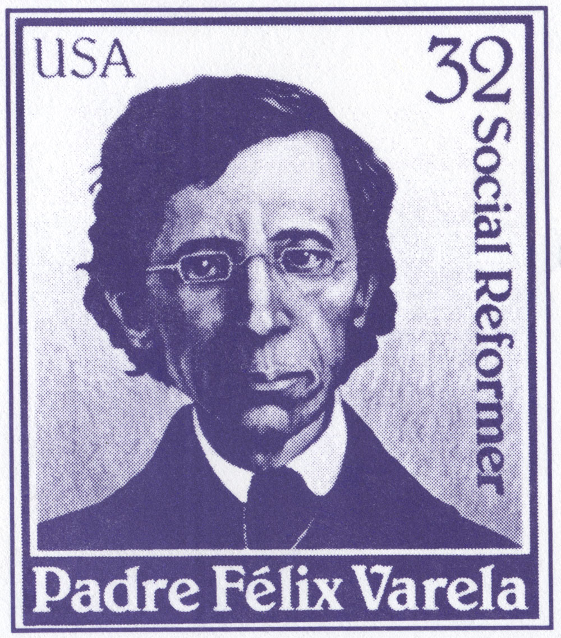 | 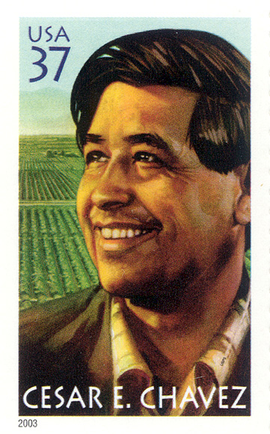

Web course Dr. Antonio de la Cova
E-mail: adelacov@mailbox.sc.edu

COURSE DESCRIPTION: An analysis of Latino immigration to the United States with a special emphasis on the diversity of the immigration experience by national origin, region of settlement, and gender. Particular attention will focus on identifying similarities between the reception of Latino immigrant groups in the U.S. and those of previous ethnic newcomers. We will also study predominant theories of international immigration, relationships between the historical and contemporary context, immigration policy, and the coping and adaptation of Latino immigrants in the U.S.

COURSE REQUIREMENTS: In order to maximize student learning, there will be textbook and BlackBoard assignment readings and YouTube documentary analysis. Students are expected to use logical arguments sustained with evidence in online discussions and to improve their reading, writing, analytical, and speaking skills.

COURSE SPECIFIC OUTCOMES: Upon successful completion of this course students will be able to:
- explain key terms, facts, and events of the Latino immigrant experience, thereby gaining an informed perspective
- comprehend the causes and effects of the ebb and flow of immigration to America
- recognize the various contributions of Latino immigrants to American society
- define the differences of social, economic, and gender roles of Latino ethnic groups
- interpret the role of religion and politics in Latino immigrant communities
- evaluate primary source material to gain insight on how to interpret Latino culture through such sources

READINGS: You are expected to read the assigned texts before each lesson posted on Blackboard. The readings will often portray opposing viewpoints to challenge intellectual inquiry. Questions regarding the texts and supplementary material posted on BlackBoard will appear on the exams and quizzes. Students are expected to be prepared to discuss the assignments when they log into Discussion Boards and Adobe Connect.

The required texts are:

Suro, Roberto. Strangers Among Us: Latino Lives in a Changing America. Vintage Press, 1999.
ISBN: 978-0679744566
Gutierrez, David G. Between Two Worlds: Mexican Immigrants in the United States. SR Books, 2001. ISBN: 0-8420-2474-3
Olson, James S. The Ethnic Dimension in American History. Brandywine Press, 1999.
ISBN: 1-881-089-87-8
GRADING: Your grade will consist of a First Exam (15%), Second Exam (20%), a Third Exam (20%), 3 quizzes (15%), 3 discussion posts (15%) and participation (15%). We will spend most of our time discussing the ideas raised in the readings. The key criteria for assessing class participation are the amount and regularity of contributions and the degree to which these are thoughtful, informed, constructive and relevant. The effort that you dedicate to this course will reflect your final grade.

Grade Breakdown
First Exam | 15%
Second Exam | 20%
Third Exam | 20%
Quizzes (3 total) | 5% each = 15%
Discussion Posts (3 total) | 5% each = 15%
Participation | 15%

SCALE: (100-90=A), (89.9-88=B+), (87.9-80=B), (79.9-78=C+), (77.9-70=C), (69.9-68=D+), (67.9-60=D), (Below 59.9= F).
ASSIGNMENTS: This course will comprise 3 learning modules with a total of 15 lessons on Blackboard. I expect you to spend 140 minutes on each lesson. Within each lesson you will find topics related to your readings, images, maps and videos. I have also provided review questions that will assist you in preparing for your exams and quizzes.

DISCUSSION POSTS: In addition your discussion responses, which comprise your participation grade, you are responsible for submitting a total of THREE discussion posts throughout the Semester. Each discussion post is worth 5% of your total grade. I will be posting discussion prompts in our Blackboard discussion board. I expect you to respond to these prompts. I may ask you a question about the material, or a video, and ask what your input based on your readings, or request you find an artifact or structure associated with the culture we are studying and post it to Blackboard, explaining what it is and how it depicts or demonstrates what we have been studying in class.
EXAMS AND QUIZZES: The three exams and three quizzes will test your mastery of course material and your ability to apply course concepts. They will be based on your readings, the information found in your course modules, including the study questions, images, maps and videos posted.

MAKE-UP EXAM: Only given under a valid physician's excuse or verified family emergency. Makeups are different and considerably more difficult essays than the regularly scheduled test.

ACADEMIC INTEGRITY POLICY: The USC Office of Academic Integrity outlines how to avoid academic dishonesty http://www.housing.sc.edu/academicintegrity/tips.html
Cheating, and phony excuse notes will be reported to the Office of Student Conduct
http://www.housing.sc.edu/osc/

DISABILITIES AND SPECIAL NEEDS
Students with documented disabilities requiring special consideration need to register with the Office of Student Disability Services the first week of class: http://www.sa.sc.edu/sds/osds/
Phone: 777-6142, TDD 777-6744
Email: sasds@mailbox.sc.edu
You may also stop by LeConte College Room 112A. All accommodations must be approved through the Office of Student Disability

